The Alternative Provision Handbook



**Contents**

|  |  |
| --- | --- |
| **Pages 3-7** | Part 1: An overview of Alternative Provision: Government guidance  **1.1: Who is the guidance for?**  **1.2: What is Alternative Provision?**  **1.3: 2023: A Three-tier model for Alternative Provision** |
| **Pages 8-15** | Part 2: Commissioning AP: What commissioners should know:  **2.1: Commissioner Responsibilities**  **2.2: Key points for consideration before commissioning Alternative Provision**  **2.3: Quality Assurance prior to placement**  **2.4: Quality Assuring Curriculum**  **2.5: Oversight of the AP Placement**  **2.6: Induction and assessment**  **2.7 Remote education**  **2.8: Reintegration**  **2.9: AP Commissioning Flowchart**  **2.10: Contacts to support with alternative provision** |
| **Pages 16 - 47** | Appendices  **Appendix 1: Alternative Provision: Audit for schools**  **Appendix 2: Alternative Provision Pre-placement Sheet**  **Appendix 2a: AP Monitoring: During Placement**  **Appendix 3: Transitions from AP to Mainstream**  **Appendix 3a: Transition Back to Mainstream: Support Package Agreement**  **Appendix 4: Inclusive Mainstream Offer: SEMH intervention examples**  **Appendix 5: Leicester City SEND Support Services**  **Appendix 6: Additional information** |

# Part 1: An overview of Alternative Provision: Government Guidance

This guidance is based upon the latest Government documentation [**Arranging Alternative Provision: A Guide for Local Authorities and Schools**](https://assets.publishing.service.gov.uk/media/67a1ee367da1f1ac64e5fe2c/Arranging_Alternative_Provision_-_A_Guide_for_Local_Authorities_and_Schools.pdf) (2025) as well as Section 19(1) of the Education Act 1996, which defines the exceptional provision of education in pupil referral units or elsewhere, such as Alternative Provision (AP) providers. These documents provide a set of guiding principles that Leicester City schools should follow to ensure that children and young people benefit from high quality provision, which is safe, secure and appropriate to their individual needs.

**1:1: Who is this guidance for?**

The term ‘commissioners’ used throughout this document refers to schools, academies and specialist providers, as well as Local Authority staff who commission Alternative Education for Children and Young People who are: -

* At risk of exclusion from school; or
* Excluded from school on a fixed term basis; or
* At risk of disengaging from mainstream education and/; or
* Require additional support during a negotiated transfer between mainstream schools; or
* Otherwise require Alternative Education provision to meet their educational entitlement, for instance in line with an Education, Health and Care Plan or is a Looked After Child with no school place.

**1.2: What is Alternative Provision?**

Alternative Provision: A Guide for LAs and schools (2025) defines AP as:

* education arranged by local authorities for children of compulsory school age who, because of exclusion, illness or other reasons, would not otherwise receive suitable education;
* alternative provision can also be used by schools for children on a suspension (fixed period exclusion);
* and for children being directed by schools to off-site provision to receive education intended to improve their behaviour.

Elective home education (EHE) and special educational provision otherwise than at school arranged under section 61 of the Children and Families Act 2014 (EOTAS) are not a form of alternative provision. EHE is a term used to describe a choice by parents to provide education for their children at home (or elsewhere) instead of sending them to school full-time. EOTAS under section 61 is arranged for children and young people with special educational needs (SEN), typically with an Education, Health and Care (EHC) plan, when it would be inappropriate for the provision to be made in a school, college or other educational institution; often due to the child’s multiple and / or complex SEN Education Act 1996 defined Alternative provision as exceptional educational provision offered in specific circumstances:

Some establishments which are classified as APs are also by default registered schools – these include PRUs, independent special schools and Children’s Hospital Schools. Establishments registered as schools can be found on the DfE website [Get Information About Schools](https://assets.publishing.service.gov.uk/media/67a1ee367da1f1ac64e5fe2c/Arranging_Alternative_Provision_-_A_Guide_for_Local_Authorities_and_Schools.pdf) .

A provider of alternative provision should be registered as an independent school if it caters full-time for five or more pupils of compulsory school age; or one such pupil who is looked after or has an Education Health Care Plan.

The DfE specify provision of more than 18 hours per week as meeting the criteria of full-time education in respect of the requirement for registration as an independent school. Alternative providers usually offer only part-time education and therefore will not need to be registered (if provision is less than 18 hours a week).

Risk assessments for placements must therefore include assurance that a provider of alternative provision is registered as an independent school if it caters full-time for five or more pupils of compulsory school age or if it caters for one pupil who is looked after or has a statement of special educational needs.

If there are any concerns that a provider may be operating unlawfully by operating provision rates above this, commissioners should seek urgent further advice from their Raising Achievement Partner or Education Welfare Officer who will escalate the matter for investigation.

The attendance of children at alternative provision remains the responsibility of the school where they are on roll. Schools should have robust processes in place to ensure they are monitoring attendance and progress of all such children. In addition, children who have part time timetables that include time at home should be monitored particularly carefully and the local authority informed when this has been arranged. Monitoring of CYP not on school rolls is the responsibility of the commissioning body.

**1.3: 2023: A Three-tier model for Alternative Provision:**

The Government’s SEND and AP improvement plan[1] (March, 2023), recommends the use of a three-tier model to define alternative provision. This model adds in-school alternative provision, within Tier 1, and emphasises that AP should be used as **an intervention, not a destination**, with fluid movement between tiers.

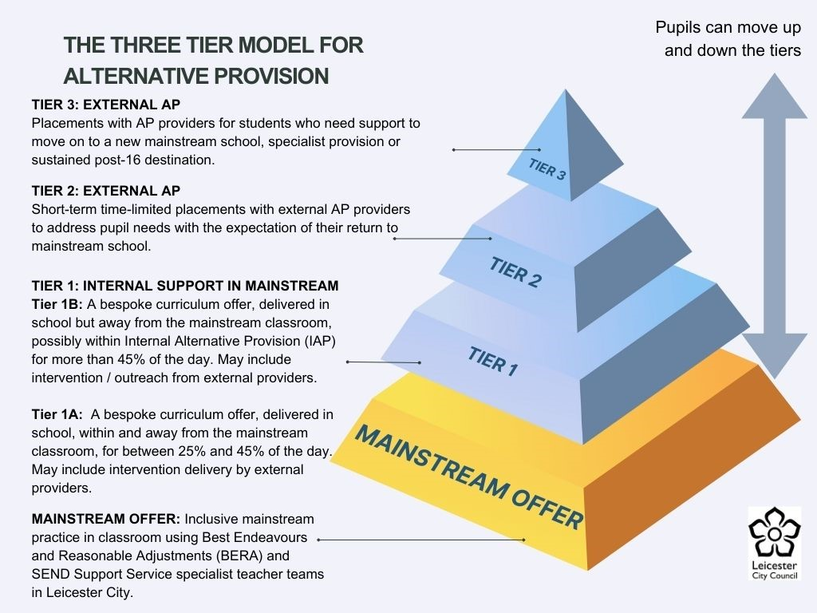

**Key Principles**

In the first instance, as part of school’s inclusive mainstream offer, the **graduated response** and the ***Best Endeavours and Reasonable Adjustments (BERA)*** should be used to meet pupils’ needs and enable continued mainstream education, accessing a broad and balanced curriculum.

This may include short-term targeted intervention, while the student remains in their classroom setting. Some examples of interventions are in (appendix 4). The student may also receive support from Local authority SEND services (appendix 5).

External providers may also be involved to provide in-school interventions e.g.:

* Forest schools and outdoor learning
* Sports activities
* Personal development sessions etc.

As part of their Inclusive Mainstream offer, schools should also make adaptations to curriculum and content, where appropriate, for example by providing alternative qualifications e.g. Functional skills qualifications, ASDAN courses etc.,

If student needs are not being met through the inclusive mainstream offer, then school may offer support at Tiers 1a or 1b.

**Alternative Provision: Tier 1**

**Targeted Support in Mainstream Schools:**

* At this level, efforts are focused on providing additional support within mainstream schools to prevent exclusion or address early signs of disengagement.
* Strategies may include personalized interventions, mentoring, and counselling.
* 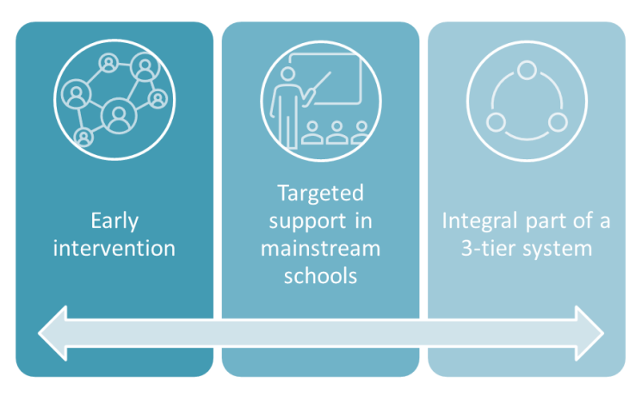The goal is to keep students within the mainstream educational environment whenever possible.

In Tier 1a, CYP will receive a timetabled bespoke curriculum within and away from their classroom for between 25% and 45% of their school day.

Where a CYP needs more than 45% of the school day away from their mainstream classroom, this may be offered within an Internal Alternative Provision (IAP) on the school site.

Both Tier 1a and 1b may include intervention delivery by external providers and outreach support such as a Mental Health Practitioner, Attendance support worker, Youth Justice Worker or Family Support worker. Outreach support from Alternative Provision, which the child accesses within their mainstream setting, may also be included.

The aim of this provision is to support CYP to remain in their mainstream school and, whenever possible, to reintegrate fully into their mainstream classroom.

Primary schools in Leicester City can join the IAP network, which runs half termly network meetings to share updates, provide advice, support and celebrate examples of good practice. Email [**Send-ap@leicester.gov.uk**](mailto:QualityInclusion@leicester.gov.uk)for more details.

**Alternative Provision: Tier 2**

**Time-Limited Placements:**

* + When students face challenges that cannot be fully addressed within mainstream schools, they may spend some time in alternative provision settings.
  + These placements should be time-limited and designed to provide specialized support.
  + 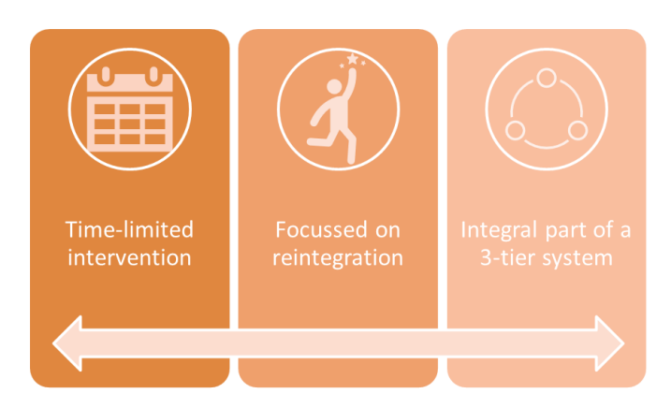Students receive tailored education and interventions to help them overcome barriers and eventually reintegrate into mainstream education.

**Key Principles:**

Tier 2 placements are in **external** alternative provision settings and should be **time limited**, with the intention of providing support to enable reintegration into the mainstream school environment.

Tier 2 provision should be planned, and the length of intervention should be clearly defined and regularly reviewed. This may be for part of the week, with the CYP attending their mainstream school for the remainder. **In exceptional circumstances this may be a short-term full-time placement (see section 2.2) but a planned end date should be established at the outset.**

Links between the CYP and the mainstream school should be maintained throughout the intervention. Reintegration planning should start early and be regularly reviewed jointly with both mainstream and alternative provision settings, as well as other relevant parties. Reintegration may involve CYP moving up a continuum of support, and rather than being placed back on a full-time mainstream curriculum, may involve an ongoing support offer, continued tier 1 interventions or graduated support, to ensure a sustained reintegration back into mainstream school (see appendices 3 and 3a).

Tier 2 placements should be chosen carefully, with appropriate checks of unregistered providers completed.

**Alternative Provision: Tier 3**

**Transitional Placements**

* + Tier 3 involves more intensive and longer-term placements in alternative provision.
  + Students who have experienced significant difficulties, such as exclusion or complex social, emotional, or mental health needs, benefit from this level.
  + The focus is on holistic support, skill development, and preparing students for successful reintegration into mainstream schools, post-16 education or other settings such as designated specialist provision or special school.

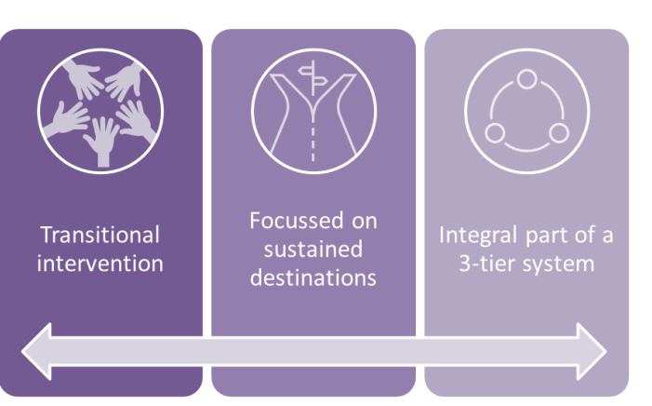These three tiers collectively contribute to a comprehensive alternative provision model, ensuring that students receive the necessary support based on their unique needs and circumstances.

**Key Principles:**

Tier 3 placements in alternative provision settings can be used to meet need in cases where a time-limited placement cannot provide the best support for individual children. These placements might be longer term, and sometimes be used where it may be more disruptive for a CYP for them to be placed back into their mainstream school. The length of intervention should be clearly defined and regularly reviewed to ensure the right support is provided to meet evolving needs. Tier 3 placements should be situated within a clear continuum of support, with processes for movement between tiers for escalation and de-escalation of support as appropriate.

Transition planning should start early and be regularly reviewed, jointly with all relevant parties. Successful transitions must be well-planned, timely, and with clear decision making and support for the CYP (see appendices 3 and 3a). This may be back into a mainstream school setting. However, depending on need, this may instead be to more specialist support where appropriate.

# Part 2: Commissioning Alternative Provision

**What AP commissioners should know**

**2.1: Commissioner Responsibilities**

Responsibility for the alternative provision used rests with the organisation commissioning the placement. **If a school receives top - up funding from the Local Authority to help finance the AP placement, the school remains the commissioner**.

**2.2: Key points for consideration before commissioning Alternative Provision**

|  |
| --- |
| AP Placements should be part-time, with at least a day a week in the mainstream setting, as stipulated below:  **Education (Pupil Registration) (England) Regulations 2006:**  **‘Legally, being a pupil and attending a school are based on physical presence. Although a school has powers to arrange some educational activities away from their premises, allowing the whole of a pupil’s education to be delivered somewhere, and by someone, other than the school means that individual is not a pupil or attending the school. Therefore, such individuals should not be registered as pupils at that school.**  **Schools can therefore only subcontract provision for pupils who:**   * **Attend the institution for at least one element of their programme throughout the academic year; and** * **Attend the school at least once a week.’**   The only exceptions to this should be if attendance at the base school would negatively impact on the CYP’s health or well-being or their ability to complete a qualification (KS4). |

Unless the CYP is experiencing barriers to education (B2E) / emotionally based school avoidance (EBSA), there is an expectation that they will be in education 5 days a week, with at least one day at their base school.

**There is an expectation that schools will have used the graduated approach and sought support from SEND Support Service link teachers or the City Psychology service, before considering Alternative Provision. These services, along with Registered APs and the Quality Inclusion Team can offer support and advice around the use of AP, commissioning queries and reintegration planning (see appendix 5).**

Commissioners should carefully consider what providers are available that can meet the needs of their pupils, including the quality and safety of the provision, costs and value for money.

**Key questions for commissioners to consider:**

* **Have the pupil, parents and relevant teacher been spoken to before a decision about alternative provision has been made?**
* **Are the nature of the intervention, objectives and timeline clearly defined?**
* **What other considerations are there, such as transport arrangements?**
* **What does the pupil want, or need, to get from the provision?**
* **How long should the provision be for?**
* **Is it part time or full time? If part-time, the pupil should attend school as usual on the days they are not in the alternative provision. If full-time, school still has responsibility for monitoring attendance and progress.**
* **How will it fit with the pupil’s mainstream curriculum? If part-time or temporary, it should complement and keep up with the pupil’s current curriculum, timetable and qualification route.**
* **What will success look like at the end of the provision?**
* **What outcomes do you hope to achieve – particularly in the areas of attendance, attitude, attainment, behaviour and positive destination?**

When it is decided that a child would benefit from alternative provision the placement should focus on enabling them to overcome any barriers to learning they may have and to assist them back into mainstream education or into a sustained post-16 destination. As such, the commissioner should always ensure that a placement will address the individual needs of the child as well as providing education in line with that of their home school to better enable re-integration. There should be discussions between the home school and local authority to ensure there are no safeguarding concerns about the location of the placement and that the route between home and provider is manageable and safe. Leicester City will be releasing an AP Directory with details for all APs known to Leicester City, Leicestershire and Rutland. **This is not a list of AP recommendations. Schools must complete their own quality assurance checks prior to the placement (see Section 2.3)**.

As soon as a suitable placement is identified, the commissioner and alternative provision setting should agree the nature of the intervention, its objectives, reintegration and the timeline to achieve these objectives. The provider should set this out in a personalised plan for the child. Plans should be linked to other relevant information or activities such as EHCPs for children with SEND.

Regular review dates (at least half-termly) between the commissioner and the provider should be built in to monitor the child’s progress against objectives and to consider any changes that may be necessary to ensure the placement is successful. This may include a visit to see the child in the provision. The provider should be responsible for advising commissioners on any necessary changes and next steps to support transitions.

Where reintegration back into a mainstream school is the main objective, there should be agreement between the home school and the provider on how to assess when the child is ready to return. A joint plan between the provider and home school should be put in place outlining the support package and resources needed from both the placement and the home or new school to help the child to reintegrate back into mainstream schooling successfully.

Support documents around transition back into mainstream can be found in appendices 3 and 4.

All objectives and plans should be agreed with all relevant stakeholders, including the parents and child, where appropriate. Objectives, plans, roles and responsibilities should be set out in writing by the provider and regularly reviewed with all stakeholders. Schools should complete an Alternative Provision Pre-placement sheet (Appendix 2) and send a copy to [**send-ap@leicester.gov.uk**](mailto:send-ap@leicester.gov.uk) at the start of the placement

When a decision is made to commission an alternative provider to offer outreach support, the mainstream school and provider should agree on the nature of the intervention, the intended outcomes, and how progress will be monitored and evaluated. Any intervention should be led by the evolving needs of the child and should be kept under review.

Where a child is on a part-time timetable in alternative provision, the commissioner of the placement and the provider should ensure there is a clearly defined plan and timeline in place for when and how the child will return to full-time education. All plans should be reviewed regularly.

If the home school refers a child to off-site provision on a part-time basis, as part of a planned intervention or placement, they should attend school as usual on the times on which they are not in the alternative provision.

(DfE, Feb 2025)

**2.3: Quality Assurance prior to placement**

Alternative Provision: A Guide for LAs and schools (DfE, 2025) highlights that the commissioner, prior to placement, should **always conduct their own due diligence** to assess whether the provision is safe, offers high quality education and is suitable for meeting the child’s individual needs.

It is **strongly recommended** that KS3/4 schools commission LEBC ([contactus@leics-ebc.org.uk](mailto:contactus@leics-ebc.org.uk), 0116 240 7000) to complete Health and Safety and Safeguarding checks on any Alternative Provision being commissioned. Currently LEBC only complete audits for KS3 /4 pupils, but they are looking to expand their offer to primary pupils. **Knowledge that an AP has previously had a successful audit by LEBC is insufficient evidence for use**. LEBC charge around £40 per pupil for an audit and will keep schools informed if any concerns around an AP are raised, during the extent of the placement. Schools who do not commission LEBC should refer to guidance in Appendix 1 for completing their own Quality Assurance checks for Health and safety and safeguarding.

**2.4: Quality Assuring Curriculum**

**To comply with OFSTED, schools should also undertake checks into the curriculum offer provided by the AP, to ensure that this meets the needs of the CYP**. A visit to the AP should be undertaken by a member of the commissioning team prior to the AP being commissioned. An **AP QA audit template is available in appendix 1** for commissioning schools to use.

Alternative provision should aim to deliver a high quality, broad and balanced curriculum that responds to the needs and ambitions of all children, giving them the foundations and resilience to succeed in education and in their future life.

The curriculum should allow for a wide range of extra-curricular activities and learning opportunities to improve life skills and experiences, aiding personal development and preparing them for the world of work.

All children should be given access to meaningful and credible subjects, courses and qualifications that will enable them to successfully take the next step into further education, employment or training.

As part of a broader curriculum there should be strong focus on English and mathematics skills and qualifications.

Given the unique nature of alternative provision and its cohort, providers also need to:

• have a strong focus on literacy and numeracy throughout the curriculum that enables children to better access wider learning and improve life outcomes

• provide a flexible curriculum that can be personalised to meet the varied needs and ambitions of all children

• enable curriculum sequencing that allows for the many different possible entry and exit points of children in a school year

• where possible, and particularly when re-integration is the aim, work closely with the child’s home school to align curriculums as far as is possible.

• deliver a curriculum that supports academic achievement whilst also aiming to address any additional needs of the child, including improving behaviour and re-engaging them in education.

Providers should use a range of appropriate assessment tools and approaches that enable them accurately to measure progress of all children regardless of their entry and exit points, and regardless of the length of time they are in the provision.

**2.5: Oversight of the AP placement**

Responsibility for the **oversight of the alternative provision used always rests with the local authority or school that commissioned the placement**. Please refer to the ***AP Commissioning Flowchart*** in section 2.9.

**Schools should always inform the local authority when they commission a placement in alternative provision for a child to ensure the local authority maintains oversight of sufficiency and safeguarding, (DfE 2025).**

**Please use the part-time timetable E-form on**  [School's Extranet (leicester.gov.uk)](https://schools.leicester.gov.uk/services/education-welfare-service/part-time-timetable-alternative-provision-notification/)

Commissioners should maintain regular contact with the provider and child, with clear procedures in place to exchange information, monitor progress and provide pastoral support. A child should not be removed from the home school’s admission register, with the school making every effort to ensure that the child continues to feel that they belong and are part of the school.

The commissioner and alternative provider should discuss and agree a proposed maximum period of time as part of the planning phase for an off-site direction. The commissioner and alternative provider should agree on appropriate reporting mechanisms, including how the provider can report any issues or concerns and how the provider keeps records on and reports back information about a child’s attendance and progress in the provision.

Commissioning schools and local authorities should maintain a full record of all placements they make, including a child’s progress, achievements and destination following the placement. This should also include the child’s own assessment of their placement. **Commissioners should complete the AP Placement Monitoring sheet (see appendix 2a) at regular intervals, during the length of the placement and send the form to** [**send-ap@leicester.gov.uk**](mailto:send-ap@leicester.gov.uk) **when the placement has been completed.**

Where a child has been directed off-site to an alternative provision school, the child should always be dual registered from the beginning of the first day on which the school has directed the pupil to attend the provision. For the purpose of the school census a child should be dual main registered at their school and dual subsidiary registered at the alternative provision.

**2.6: Induction and assessment**

As a child can enter alternative provision at any point in their school career and at any point in the academic year, it is essential that robust induction and baselining take place.

Prior to the placement starting, all relevant information should be shared with providers and other parties (home school, parents, relevant agencies) involved in the placement. This should be jargon free and include any information on SEN, disability or medical need, literacy, safeguarding or other issues, as well as any information requested by the provider as appropriate. Information must be provided in accordance with data protection principles but this should not discourage schools from providing information where they can appropriately do so. Guidance on information sharing for people who provide safeguarding services to children, young people and parents can be found in [Information sharing advice for safeguarding practitioners](https://www.gov.uk/government/publications/safeguarding-practitioners-information-sharing-advice).

A well-structured induction plan will start the process of building a positive relationship between provider and the child. An induction also allows the provider to understand the child’s background, experience and needs as soon as they enter the provision. This will enable the provider to tailor the curriculum, the required support and interventions to the child’s individual needs, greatly improving their initial experience and ultimately improving outcomes.

The induction should include an assessment of the child’s current academic levels and an opportunity to establish their future ambitions. This will enable the provider to put in place a personalised learning plan that includes an appropriate curriculum, alongside any additional SEN or learning support the child may need. During the induction the provider should also baseline the child’s previous attendance and engagement with education. This will enable them to effectively track and monitor patterns of absence, future attendance and engagement and demonstrate improvements that are made.

Where possible, engagement with parents should also be part of the initial induction plan.

**2.7: Remote education**

Attendance is essential for children to get the most out of their school experience, including for their attainment, wellbeing, and wider life chances. Remote education should not be viewed as an equal alternative to attending school. For this reason, we expect schools to consider it only as a last resort when the alternative would be no education, and only after it has been established that the child is, or will be, absent from school. In such cases, remote education can have the benefit of allowing absent children to keep on track with their education and stay connected to their teachers and peers in some cases.

For some children with health needs that mean they cannot attend school, it may be advisable to only use digital learning for a limited period of time. Guidance on appropriate use of remote education can be found in [Providing Remote Education](https://www.gov.uk/government/publications/providing-remote-education-guidance-for-schools).

For some pupils who are experiencing barriers to their engagement in education – for example pupils with emotionally based school avoidance (EBSA) – remote learning can be used as a way of restarting and increasing their engagement in learning and in building connections with key members of staff. Keeping a log of engagement in these sessions in addition to the attendance register can demonstrate how levels of engagement are being monitored and increased where possible.

**2.8: Reintegration**

When a child is placed in alternative provision during a suspension of more than five school days, or a child has been directed off-site to improve their behaviour, the home school and provider should agree a plan and process at the beginning of the placement that aims to reintegrate the child successfully back into their home school. The plan should include details of how to assess when the child is ready to return to their home school and should provide an appropriate package of support, from both provider and home school, to assist their reintegration.

The placement should be regularly reviewed, including through regular contact or visits to the provider, and the plan and timetable for reintegration should be adapted as necessary. The home school should receive regular reports from the provider on the child’s achievements and progress, including on their attendance and behaviour management, during the placement. A final report should be produced in anticipation of the child returning to their home school.

When the placement is due to come to an end a discussion should take place between the home school, provider, child (if age appropriate), parent and any relevant external agencies to confirm reintegration arrangements and agree any additional support the child may need, and who will provide it, in order for their return to mainstream school to be a success (see appendices 3 and 3a).

The home school and provider may want to negotiate continued support for the child once they have returned to their home school to ensure they settle back into the mainstream and reintegrate successfully and sustainably.

If the placement does not end with reintegration into the school – for example, when a child reaches the end of Y11 while still in alternative provision – the provider and home school, if appropriate, should have a plan in place to secure a successful destination into further education, training or employment.

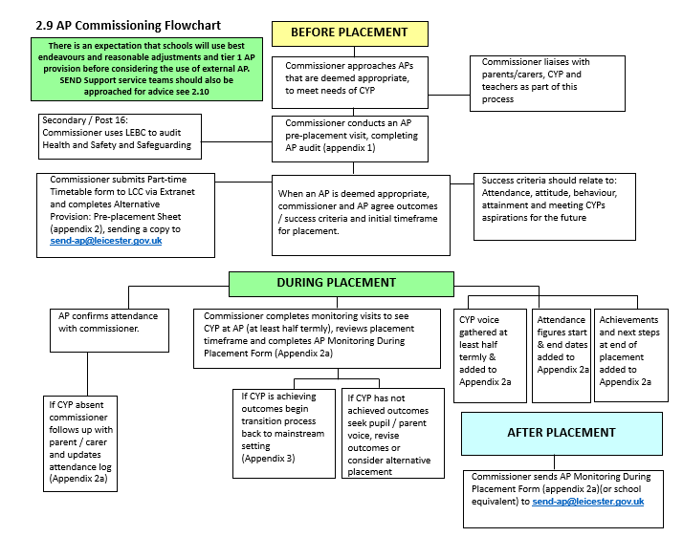

**2.10 Contacts to support with use of Alternative Provision**

|  |  |  |
| --- | --- | --- |
| **Quality Inclusion Team** | Michelle Deeming – AP Lead Teacher | [send-ap@leicester.gov.uk](mailto:send-ap@leicester.gov.uk)  01164544650 |
| **Social Emotional and Mental Health (SEMH) Team** | Schools link teacher or email the SEMH inbox | [SEMH@leicester.gov.uk](mailto:SEMH@leicester.gov.uk)  01164544650 |
| **Learning Communication and Interaction (LCI) Team** | Schools link teacher | Link teacher email  01164544650 |
| **City Psychology Service (CPS)** | Schools link EP | Link EP email  01164544650 |

# Appendix 1: Alternative provision - Audit for schools

(based on documentation developed by Elmbrook school)

|  |  |  |  |  |  |  |
| --- | --- | --- | --- | --- | --- | --- |
| Name and address of alternative provider: |  | | | | Name of contact(s) at the alternative provision |  |
| Listed on GIAS? | YES? |  | NO? |  | Website |  |
| URN: |  | | | |
| Date and time of visit: |  | | | |
| This audit has been completed by: |  | | | |

Safeguarding

| Questions | Answer (plus Evidence) | | | | COMMENTS |
| --- | --- | --- | --- | --- | --- |
| Is the provider Ofsted registered?  If so, under what status?  School? Voluntary childcare? |  | | | |  |
| Do 4 or more pupils, or 1 with and EHCP, attend full time?  *If so the provider should be registered as a school on GIAS, otherwise operating illegally* |  | | | |  |
| If registered, how did Ofsted judge safeguarding in the last report? |  | | | |  |
| What were the results of the AP’s most recent safeguarding audit?  *Ask to see the AP’s safeguarding action plan* |  | | | |  |
| Who is / are the designated DSL(s)? |  | | | |  |
| Provider has been supplied the school’s safeguarding policy? | YES | COMMENTS | | | |
| Are all safeguarding policies and procedures in place, like:   * Child protection and safeguarding? * RSE? * Health & Safety? * Code of Conduct? * Behaviour?   *Look at the AP’s policies*  *Talk to the AP to make sure it’s implementing the policies* |  | | | |  |
| Is there a staff and volunteer record?  *Single central record of qualifications, recruitment and vetting checks.* |  | | | |  |
| Are Safer Recruitment procedures in place?  *Ask to see the Safer Recruitment policy* |  | | | |  |
| Have DBS checks been completed for staff?  *Ask to see evidence of these* |  | | | |  |
| Is there a policy / procedure for dealing with allegations against staff? |  | | | |  |
| What safeguarding training have the AP staff had?  *Look at safeguarding training log*  *Was the training in line with the most recent updates?* |  | | | |  |
| When was the most recent training? |  | | | |  |
| Are staff trained in the use of physical intervention?  *What was the training?*  *Look at training logs.* |  | | | |  |
| If there was an incident involving a physical intervention, how is it recorded, reported to parents, to us? |  | | | |  |
| Will the pupil have contact with any other people?  *E.g., member of the public* |  | | | |  |
| Are risk assessments in place?  For the premises?  For the activity(ies)?  For the pupils?  *Ask to see the risk assessments* |  | | | |  |
| Any other comments? |  | | | | |
| Information relating to any behavioural issues / risks posed by the pupil have been shared with the provider. | YES | | NO | COMMENTS | |

Insurance: Recommended levels of cover

| Questions | Answer (plus Evidence) | comments |
| --- | --- | --- |
| Public Liability  *Minimum of £5M in respect of any one act, or occurrence, or series of acts / occurrences in any one year* |  |  |
| Employer’s Liability  *Minimum of £10M in respect of any one act, or occurrence, or series of acts / occurrences in any one year* |  |  |
| Professional Negligence  *Minimum of £2M in respect of any one act, or occurrence, or series of acts / occurrences in any one year* |  |  |
| Motor Insurance  *Required for the operation of any vehicles used to transport pupils* |  |  |
| Other? |  |  |

The onus is on the provider to ensure its insurance policies are always adequate to cover eventualities pertaining to its business, but the school also holds a responsibility to its pupil.

Quality of education

| Questions | Answer (plus Evidence) | comments |
| --- | --- | --- |
| If registered, how did Ofsted judge the quality of education in the last report?  *Look at:*   * *Recent Ofsted report* |  |  |
| What did you see on your learning walk?  *Look for:*   * *Pupil engagement* * *Pupil behaviour* * *Pastoral support* * *Quality of teaching* * *Adult-pupil interaction*   *The needs of pupils with special educational needs and/or disabilities are being met* |  |  |
| Will the curriculum offer meet the educational and SEMH needs of your pupil?  *Look at:*   * *Curriculum offers* * *How lessons are differentiated to meet all pupils’ needs?* * *Are there therapeutic objectives / outcomes?* |  |  |
| Are the premises fit for purpose?  *Are they appropriate to the planned activities / course?*  *Are the premises secure?*  *Are they accessed by members of the public?* |  |  |
| Do pupils enjoy learning?  *Look for evidence of this on your learning walk*  *Are pupils:*   * *Engaged in learning?* * *Being challenged?* * *Making progress?* * *Can the AP show you any positive feedback / reviews* |  |  |
| How does the AP’s behaviour policy support pupils’ personal development?   * *Ask for a copy of the behaviour policy* * *Look for evidence on your learning walk* |  |  |

Transition process and procedures

| Questions | Answer (Plus Evidence) | comments |
| --- | --- | --- |
| What are the AP’s induction arrangements? |  |  |
| Does it offer any taster sessions? |  |  |
| Can the pupil visit the provision before they start attending? |  |  |
| What does a typical transition timetable look like? |  |  |
| How does the AP reintegrate pupils back into mainstream education? |  |  |
| How does the AP determine whether a pupil is ready to be reintegrated into mainstream education? |  |  |
| Does the AP provide a suitable range of courses and subjects to help pupils to reintegrate back into school or to move onto further education/college? |  |  |

Communication and information sharing

| Questions | Answer (plus Evidence) | comments |
| --- | --- | --- |
| How does the AP track attendance? |  |  |
| How will the AP let you know your pupil’s attendance?  *Is this daily? Do they do safe and well checks at home? If not, school will have to* |  |  |
| How do we share any specific learning concerns we may have about our pupils with the AP? |  |  |
| How will the AP tell us about our pupils’ progress?  *Ideally weekly updates* |  |  |
| Will the AP attend pupil reviews? |  |  |
| How does the AP communicate with parents? |  |  |
| How does the AP assess learning?  What pupil progress checks does it do?  *Look at assessment policy* |  |  |
| What outside agencies does the AP work with?  *Ask about outside agencies such as:*   * *Social care services* * *Educational psychology services* * *Child and adolescent mental health services* * *Youth offending teams* * *Drug support services* |  |  |
| How does the AP support pupils pastorally? |  |  |
| If your pupil has concerns about safeguarding or well-being, who do they speak to? |  |  |
| What are the AP’s complaints procedures?  *Look at the complaints policy* |  |  |

Look at any concerns and further actions that the audit has revealed to decide if the provision is suitable.

| is this AP suitable | Give reasons for your answer |
| --- | --- |
| Yes |  |
| No |  |

# Appendix 2: Alternative Provision – Placement Sheet

|  |  |
| --- | --- |
| Pupil Name |  |
| Pupil UPN |  |
| SEND (tick if appropriate)  EHCP |  |
| LAC (inc post-LAC) (tick if appropriate) |  |
| Has all appropriate information been shared with provider?  (inc. contact details, EHCP etc) |  |
| Name and role of staff member who completed quality assurance on-site visit of provider (please attach completed QA audit): |  |
| Registered (tick if appropriate): |  |
| Unregistered (tick if appropriate): |  |
| Hours attending per week:  **Please attach a detailed timetable showing curriculum in AP and mainstream setting** |  |
| Following feedback from QA audit, are SLT satisfied the provision meets the needs of the pupil? |  |
| How long will the pupil remain at the alternative provider? |  |

|  |
| --- |
| Why do leaders consider this provision to be the best option for the pupil concerned? If unregistered, please specify why an alternative registered provider cannot be identified. |
| If KS3 / 4 long term placement: What course will be undertaken, including qualification/ accreditation? |
| What are the learning outcomes / success criteria for the placement? |
| How will you monitor the attendance, progress and behaviour of the pupil? |
| How does the provision promote the pupils’ personal development? |
| How will transition into and out of the alternative provision be managed? |

|  |  |  |  |
| --- | --- | --- | --- |
| **Headteacher signature:** |  | **Date:** |  |

**Please return sheet to Send-ap@leicester.gov.uk**

**Appendix 2a**

**AP Monitoring: During Placement**

|  |  |  |  |
| --- | --- | --- | --- |
| **Student Name** |  | **Student ID** |  |
| **Alternative Provision name:** |  | | |
| **Placement Start Date:** |  | **Placement End Date:** |  |

**Record of Attendance in AP:** if school use a data tracking system (e.g. Collaborative Learning Manager) linked to the AP, their reports can be shared instead of this form.

Please use code APP – present; APA – absent for any days CYP is required to attend AP and SP -present; SA – absent for days CYP is required to attend school (duplicate page as necessary)

|  |  |  |  |  |
| --- | --- | --- | --- | --- |
| Mon | Tue | Wed | Thu | Fri |
|  |  |  |  |  |
|  |  |  |  |  |
|  |  |  |  |  |
|  |  |  |  |  |
|  |  |  |  |  |
|  |  |  |  |  |
|  |  |  |  |  |
|  |  |  |  |  |
|  |  |  |  |  |
|  |  |  |  |  |
|  |  |  |  |  |
|  |  |  |  |  |
|  |  |  |  |  |
|  |  |  |  |  |
|  |  |  |  |  |
|  |  |  |  |  |
|  |  |  |  |  |
|  |  |  |  |  |
|  |  |  |  |  |
|  |  |  |  |  |
|  |  |  |  |  |
|  |  |  |  |  |
|  |  |  |  |  |
|  |  |  |  |  |
|  |  |  |  |  |
|  |  |  |  |  |
|  |  |  |  |  |
|  |  |  |  |  |
|  |  |  |  |  |
|  |  |  |  |  |

**Monitoring Visit notes:**

|  |  |  |
| --- | --- | --- |
| Visit date | Notes: Must include voice of pupil, well-being, safety and progress.  Must re-confirm provider continues to complete all safeguarding checks. | Current attendance % |
|  |  |  |
|  |  |  |
|  |  |  |
|  |  |  |
|  |  |  |
|  |  |  |

**End of AP Placement Summary**

|  |
| --- |
| **Progress made against outcomes / success criteria** |
|  |
| **Views of CYP about the placement** |
|  |
| **Views of parents/carers about the placement** |
|  |
| **Next steps** |
|  |

**Please return to** [**Send-ap@leicester.gov.uk**](mailto:QualityInclusion@leicester.gov.uk) **at the end of the AP placement**

# Appendix 3: Transitions from AP to Mainstream

What is Mainstream ready?

This document has been produced to provide guidance to mainstream schools who may be asked to receive children who have been deemed mainstream ready after a period of time with alternative settings (e.g. PRU, Hospital School, Alternative Provisions, Special Schools, DSPs). It should be used alongside the BERA document ([leicester-city-s-bera-framework-delivering-high-quality-send-provision-the-application-of-best-endeavours-and-reasonable-adjustments-within-a-mainstream-setting.pdf](https://schools.leicester.gov.uk/media/7104/leicester-city-s-bera-framework-delivering-high-quality-send-provision-the-application-of-best-endeavours-and-reasonable-adjustments-within-a-mainstream-setting.pdf), see page 8 for links to specific areas of needs, e.g. SEMH, ASD).

|  |  |  |
| --- | --- | --- |
| Mainstream ready usually means | This does not mean | But might mean |
| They have engaged positively with support | They can manage without support | Would benefit from check-ins  might need to have interventions planned in to the timetable |
| They have established a reliable way of working | They can manage without support  They can attend full time  They don’t need adaptations | They will benefit from a visual timetable  They will need to know about any changes to their routines |
| They are mostly attending | They will attend for 100%  They will function well all day every day  They are brought to school reliably | Attendance is improving over time  You will have plenty of opportunities to work with them |
| They have ambitions to be taught | They are in top sets  They can be in school full time | You can motivate them to re-engage after a difficulty  You can get them excited about trying a new task. |
| They can build relationships with staff | They will always remember how to talk to them | They can build a trusting relationship with one or a small number of staff in school. |
| They want to be with their peers | They will always manage all their peer relationships  They want to be with their peers all the time | They need some social support (e.g. circle of friends, Talkabout, good role models, social interaction support, turn taking) |
| They can use appropriate communication skills | They will be able to always use positive language  They may not need reminders about listening and allowing others to speak | They can make themselves understood  They can help to negotiate a good resolution to difficulties |
| Is respectful of own objects (or work), and that belonging to others / the school | They will always ask permission to borrow something  They will never damage any items if distressed | They will take pride in their work |
| They can acknowledge own strengths and weaknesses | They will always accept praise  They can manage without support  They can manage disappointment when finding things difficult | They can ask for help (maybe from their key adults) |
| They can be successful in a supportive environment that will value and invest in them | They will not test you to see if you are going to reject them | You may need to say and do things repeatedly, and deliver, before they believe you are going to support them |

|  |  |
| --- | --- |
| They might need | This does not mean |
| A mentor/classroom assistant in school | Someone to talk to only after things have gone wrong  They will always or never be able to work independently |
| An adapted curriculum or some outdoor learning | They need to be on vocational placements or be off-site throughout the week |
| Meeting and greeting and a check in | After two weeks (or ever) that they will be ok on their own |
| A reduced timetable initially | They will never manage full time |
| An agreed safe space within school | They will only need to access it when things have gone wrong |
| Targeted intervention(s) | They are not able to manage the classroom |
| Support at unstructured times and transition times | They will need constant supervision |
| More support than their peers to be organised for their day | They will not be able to engage with their learning and be positive members of their community |
| Support to understand and manage their emotions | They will not be able to self-regulate |

|  |  |  |
| --- | --- | --- |
| In moments of weakness they might | This means (the bad news) | This means (the good news) |
| Feel their emotions fiercely | They may react too quickly and get into conflicts with staff and students | Given a little time to process they should be able to manage so staff will be able to help them with that |
| Bring difficulties from home | Might be distracted, agitated, look tired and disengaged | If they know their value, they will try hard (enough) in school |
| Be overly invested in the opinion of their peers | They may make bad decisions | They need help to refocus on what other important people want for them (and what they really want for themselves) |
| Be unable to think positively about themselves or school | They may lash out at those around them or damage their work / equipment | They need restorative conversations to remind them of their strengths. With support they can build resilience to learn from failure |
| Resort to fight, flight or freeze | They may hurt others or may run away from school | You have the opportunity to recognise that the child is distressed  You can build better strategies together |

Some students in and returning to mainstream school will continue to require support. Additional support for pupils experiencing difficulties in these areas include:

* BERA document
* School based assessments
* Outside agency support (e.g., EP, SEMH Team or LCI Team)
* Speech Language and Communication Assessments
* Access to behaviour support interventions from LPS
* Access to Alternative Provisions
* Apply for Element 3 funding or an EHCP
* Developing the use of key adults
* Referral to Early Help or Social Care

**Appendix 3a: Transition Back to Mainstream – Support Package Agreement**

All pupils transitioning back to mainstream, from a registered alternative provision, will have a support package agreed, elements from below can be identified for individual pupils to aid and support transition.

Pupils should not be considered for change of placement if EHC assessment is in progress.

Pupils should be dual registered for the agreed transition period.

Pupil’s Name: DOB

Transition from: (setting) To: (school)

Agreed transition period (this should be at least 6-8 weeks):

Highlight below what personalised elements of support have been agreed to support transition for the pupil.

|  |  |  |  |
| --- | --- | --- | --- |
| Support Service | What support could look like | Available to (and cost if applicable) | Contact |
| SEMH Team - link teacher support | * Liaison between setting and schools * Assessments * Circle of adults * Additional Team Teach workshops | All pupils on caseload  Cost for school’s dependant on SEMH package.  Available as traded  Available for all key stages (with involvement of EYST if required) | Schools link teacher or  [SEMH@leicester.gov.uk](mailto:SEMH@leicester.gov.uk) |
| SEMH Team – practitioner support | * Direct work with pupils in both setting and school to support transition * Continuation of interventions through training for school staff or continuation of intervention delivered by SEMH practitioner | All pupils on caseload  Cost for school’s dependant on SEMH package etc.  Available as traded | Schools link teacher or  [SEMH@leicester.gov.uk](mailto:SEMH@leicester.gov.uk) |
| Elmbrook School  (Primary PRU) | * **ALL pupils -** Safeguarding discussion * Liaison between PRU, school, SEND Services (LCI/SEMH) and parents * Bespoke transition – length of time will be dependent on pupil. * Review meeting involving all professional and parents * Circle of adults or detailed discussion * Sharing of documentation and plans (e.g. PHP) * Potential of part-time or phases placement during transition | All schools:  mainstream primary | [office@pru.leicester.sch.uk](mailto:office@pru.leicester.sch.uk) |
| PRUs, SEMH, other SEND services | Support application for E3 and EHCP funding for receiving school where appropriate. This may be increased for duration of transition period. | All schools |  |
| New mainstream setting | * Key adults spending time in setting to develop relationships with the pupil. * Transition booklet * Visits * Attendance at professionals meeting * Professionals observe pupil in each setting. * Commitment to train in and/or provide support to meet individual pupils needs. This may include a continuation of interventions | All pupils |  |
| LCI | * Liaison / meeting between school / AP. * Support and advice for creating transition tools e.g. social stories as required * Direct work with pupils in both setting and school to support transition as needed * Continuation of strategies / intervention for school staff through modelling delivered by LCI Teaching Assistant. | Pupils already on LCI caseload  or prioritised for referral at JPM by school as part of agreed Service Level Work.  Work additional to SLA can be requested as traded work | Contact schools link LCI teacher. |
| City Psychology Service | Schools are able to consult their link EP to the school, support is available where Psychology Service involvement is prioritised by the school using their allocated time or time from within their additionally purchased Service Level Agreement. | All pupils where involvement is requested | Contact schools link EP |
| Hospital School | Safeguarding review and updates  Liaison between CHS and school  Bespoke transition – length of time will be dependent on pupil.  Review meeting involving all professionals.  Professionals supporting pupil in each setting where appropriate including:   * opportunities for staff from receiving school to work with student in CHS provision and * CHS staff to support in school as part of agreed plan   Identification of trusted adults and safe places in school  Sharing of documentation and plans  Continuation of part-time placement during transition  Attendance tracking  Family Support Worker contact with families  Transition Coordinator to be first point of contact for family and school during placement and on discharge. | All pupils with previous hospital school involvement | Contact transition co-ordinator  [wbadmin@childrenshospitalschool.leicester.sch.uk](mailto:wbadmin@childrenshospitalschool.leicester.sch.uk) |
| Secondary PRU | * **ALL pupils** - Safeguarding discussion * Liaison between PRU and school * Transition plan to include offer of in school mentoring for time limited period'. * Review meeting involving all professional. * Professionals observing pupil in each setting. * Sharing of documentation and plans (e.g. PHP) * Potential of part-time placement during transition * Continuation of interventions through training for school staff or continuation of intervention delivered by PRU staff. | All pupils | [office@lps.leicester.sch.uk](mailto:office@lps.leicester.sch.uk) |

**Assessments to support transition**

Setting to highlight which assessments have been completed to support mainstream school’s understanding of the pupil.

|  |  |  |  |
| --- | --- | --- | --- |
| Assessment | Age range suitability | Useful for | Other information |
| Boxall Profile | Primary and Secondary versions | Identification of areas of need for pupils with attachment issues. Beyond the Boxall provides suggestions re. activities to support areas of need. | Needs to be completed by professionals who know the pupil well |
| Readiness for reintegration | Primary and Secondary PRU | Identification of strengths and needs for re-integrations |  |
| One page profile | Primary PRU | Summary of pupils |  |
| Referral priority sheet | Secondary PRU | 3 key behaviours to measure at LPS and back in school. |  |

# Appendix 4: Inclusive Mainstream Offer: SEMH intervention examples

|  |  |
| --- | --- |
| **Developing Positive Relationships** | * Positive People * Friendship / Social Interaction groups |
| **Understanding Emotions** | * Managing Feelings group |
| **Regulating Emotions** | * Relaxation sessions * Mindfulness interventions * Understanding and Managing anxiety – CBT informed * ELSA support * Zones of Regulation * Regulating Techniques * Modelling * Prompting / helping * Self-talk * Relaxation * Sensory breaks * Following the child’s lead * Redirection of attention * Active ignoring * Reassurance * Emotional following * Physical comfort * Vocal comfort |
| **Outdoor/nature education** | * Forest school * Therapy Dog * Outdoor learning |
| **Creative outlets** | * Music therapy * Dance therapy * Art therapy * LEGO Therapy * Play Therapy * Yoga therapy * Sensory circuits |

**Appendix 5: Leicester City SEND Support Services**

|  |  |
| --- | --- |
| Social, Emotional and Mental Health Team | The Social Emotional and Mental Health Team (SEMH) is skilled and experienced specialist teachers and practitioners, who provide support to schools and colleges in meeting the needs of children and young people experiencing SEMH related challenges.  The team offer a fully traded service, meaning that schools and colleges are able to purchase support following referral. |
| City Psychology Service | Educational psychologists (EPs) work in early years’ settings, schools, community settings and family homes.  EPs have training in child development and psychology and work in partnership with parents, carers, setting/school staff and other professionals to support the development, learning and emotional well-being of children and young people. |
| Learning Communication Interaction Team | The learning, communication and interaction (LCI) team aims to provide efficient and effective support on an individual, group or whole school basis for pupils with learning, communication and interaction special educational needs. |
| Hearing Impairment Team | In Leicester City, the Hearing Support Team works with schools and families to ensure that your child fully accesses school life and that their hearing needs are met.  All children and young people with a unilateral or bilateral hearing loss will be supported from birth and throughout their years in education. The Hearing Support Team visit children and young people at home, in settings and schools. |
| Vision Support Team | In Leicester City, the Vision Support Team works with schools to ensure that your child fully accesses school life and that their visual needs are met.  The team support children with a visual impairment (VI) and their families from birth and throughout their years in school. |
| Early Years Support Team | The Early Years Support Team provides inclusive support to young children 0-5 with special educational needs and their families. We provide a wide range of child focused and parent/carer activities, in addition to providing advice and training to staff working in settings and schools. |
| Quality Inclusion Team | The Quality Inclusion Team sits within SENDS Support Services to support the embedding of inclusive practices within our mainstream settings, schools and colleges. This includes work on: the BERA audits; Element 3; Designated Specialist Provisions; Quality Assurance processes; Transformation; Bandings and Tariffs and Alternative Provision. |

**Registered Alternative Provisions**

**The Children’s Hospital School**,

Leicester Royal Infirmary, Infirmary Rd, Leicester LE1 5WW

Tel: 0116 258 5330

[childrenshospitalschool.leicester.sch.uk](https://www.childrenshospitalschool.leicester.sch.uk/)

* Magpie Learning Centre

The Magpie Learning Centre provides education for pupils in Years 5-10 who are finding it difficult to access education in their own school due to mental and / or physical health. There are two different pathways available at the Magpie Learning Centre.  Full time pupils follow a personalised timetable comprising both academic and therapeutic elements. Those attending one of our part-time intervention groups will have a timetable designed to meet their specific needs.

* Willow Bank School

Willow Bank School is for students aged 11-16 who are unable to access education in their own school for medical reasons.

**Leicester Partnership School (Secondary Behaviour support service)**

Carisbrooke Specialist Learning Centre, Carisbrooke Gardens, Leicester, Leicestershire, LE2 3PR,

Tel: 0116 303 3281

Website: lps.leicester.sch.uk

The Leicester Partnership School (LPS) provides a range of educational provision for young people, between the ages of 11-16 years, who have been excluded, or who are at risk of exclusion, from mainstream education.

**Elmbrook School (Leicester City Primary Pupil Referral Unit)**

Leicester City Primary PRU, 231 Netherhall Rd, Leicester LE5 1DT

Telephone: 0116 208 1470

Website: pru.leicester.sch.uk

# Appendix 6 - Additional Information:

* **Health and safety**

The Health and Safety at Work Act 1974 places a duty on employers, including alternative education providers to ensure, so far as is reasonably practicable, the health, safety and welfare at work of its employees, and others who are affected by their activities such as young people on educational placements.

Under the Management of Health and Safety at Work Regulations 1999, employers have a responsibility to ensure that young people at work (including those attending alternative education provision) are not exposed to risk due to lack of experience, being unaware of existing or potential risks and/or lack of maturity, physical capability etc.

LCC follows the current guidance by the [Health and Safety Executive (HSE).](http://www.hse.gov.uk/) This information should be referred to in conjunction with this guidance. Key points: The alternative education provider (employer) has primary responsibility for health and safety of the pupil and should be managing any significant risks. **Commissioners should take reasonable steps to satisfy themselves that providers are doing this.**

Those commissioning and organising alternative education provision must be competent and ensure it is appropriate for pupils concerned. Provision must be age appropriate and take into consideration any pupils who might be at greater risk, for example due to health conditions or special educational needs, so this can be taken into account when planning the placement. This should include details of any medical or behavioural circumstances as well.

Commissioners should discuss with the provider what the pupil will be doing during the placement, noting any relevant precautions. The alternative education provider (employer) can include specific factors for young people into their existing risk assessment as appropriate.

Providers must inform parents/carers of any significant health and safety risks to their child on placement and how they are being controlled. Providers must also inform the commissioner / school.

When commissioning alternative education provision, relevant health and safety information should be obtained to assess the suitability of the provider. The government’s Crown Commercial Service Standardised Pre-Qualification Questionnaire includes information on health and safety which should be considered as part of the process when commissioning alternative education provision. The Institution of Occupational Safety and Health (IOSH) have also produced a public service procurement health and safety checklist which can be used to consider key health and safety issues. These lists are not exhaustive, and commissioners should ensure that adequate health and safety information is obtained.

It is the responsibility of commissioners to decide the extent of checks that are carried out when commissioning provision. This will be based on the type of environment and potential risks involved within the placement. Checks should be kept in proportion to the risks involved.

In lower risk environments, information gained may be relatively straight forward and limited, whilst in environments with less familiar risks or for those in higher risk environments, such as construction, agriculture, manufacturing or motor vehicle repairs, as well as workshop/machinery environments etc., the checks will need to be more robust.

Commissioners should satisfy themselves that adequate health and safety arrangements are in place and the work the pupil will be doing is being effectively managed to ensure their health and safety. This will need to consider induction, training, supervision, site familiarisation and any protective equipment that might be needed etc. In addition, pupils should know how and who to raise health and safety concerns.

Commissioners should also check that the provider understands about the specific factors relevant to young people at work, including certain industry specific prohibitions and limitations.

For all environments, Leicester City Council strongly recommend that a physical check of the provider and placement is carried out by a competent person. A competent person is somebody who has suitable training, skills, experience and knowledge. Physical checks should look at the general suitability of workplace conditions, housekeeping, toilets and washing facilities, fire precautions, guarding of machines, provision of any necessary protective equipment etc. This list is not exhaustive and there may be other important aspects to consider dependent upon the type of environment and risks involved.

There should also be agreement on key points of contact between the provider and school during the placement to discuss any issues or concerns. This includes the reporting of any serious accidents or incidents to the school who should follow their own employer’s accident reporting procedure.

Commissioners should carry out appropriate monitoring throughout the placement to satisfy them that providers are continuing to manage the health and safety of pupils on placement. This could be undertaken as part of a general quality assurance visit to assess the overall effectiveness of the provision. Health and safety checks should be undertaken by a competent person and be kept in proportion to the environment and risks involved. Checks should be recorded.

Providers should complete the Statement of Significant Risks & Control Measures Form. For further information and advice, commissioners should contact their health and safety advice provider. For more information on health and safety competent advice, refer to: [hse.gov.uk](http://www.hse.gov.uk/)

* **Safeguarding**

Where a child is placed in alternative provision, the commissioning school or local authority continues to retain safeguarding duties towards the child and should therefore be satisfied that the provision is in a safe environment as well as meeting the child’s pastoral and educational needs.

Commissioners should obtain written confirmation from the alternative provider that appropriate safeguarding checks have been carried out on individuals working at the establishment, i.e. those checks that schools would otherwise perform in respect of their own staff. This includes written confirmation that the alternative provision provider will inform the commissioner of any changes to arrangements that may put the child at risk, e.g. staff changes, so that the commissioner can assure itself that appropriate safeguarding checks have been carried out on new staff.

When a child is attending an alternative provision school, the commissioner should ensure that they have arrangements in place whereby all absence is followed up promptly, particularly unexpected and unexplained absence.

When a child is placed in a college or unregistered alternative provision setting, the commissioner should also ensure that they have arrangements in place whereby the provider of the educational activity notifies them of any absences by the child. The commissioner should always know where the child is during school hours. This includes having records of the actual address of the commissioned alternative provider and any subcontracted provision or satellite sites the child may attend.

Commissioners should regularly review placements they make in alternative provision. Reviews should be frequent enough (at least half-termly) to assure that the provision is achieving its objectives, that the child is regularly attending, and that the placement continues to be safe and meets the child’s needs.

Where safeguarding concerns arise, the placement should be immediately reviewed and terminated, if necessary, unless or until those concerns have been satisfactorily addressed.

Schools and local authorities should always have regard to Keeping Children Safe in Education guidance and Working Together to Safeguard Children.

Safeguarding and promoting the welfare of children and young people is everyone’s responsibility. Everyone who meets children and their families has a role to play. To fulfil this responsibility effectively, all providers should make sure their approach is child centred. This means that they should consider, always, what is in the best interests of the child/young person.

Safeguarding and promoting the welfare of children (all young people under the age of 18) is defined for the purposes of this guidance as:

* protecting children from maltreatment;
* preventing impairment of children’s mental and physical health or development;
* ensuring that children grow up in circumstances consistent with the provision of safe and effective care; and
* taking action to enable all children to have the best outcomes.

Commissioning schools must satisfy themselves that providers are familiar with LCC’s Safeguarding Children Partnership procedures and protocols for safeguarding the welfare of their pupils in alternative provision. Providers must have a Designated Safeguarding Lead and deputy and have undertaken the relevant and appropriate training.

Commissioning schools retain responsibility for the process of making referrals to children’s social care and for statutory assessments under the Children Act 1989 and any role they might be expected to play in such assessments (KCSIE).

**DfE statutory guidance on alternative provision.**

**Proposed National Standards**

**1. Safeguarding and the wellbeing of children**

**a) All staff and proprietors have appropriate recruitment checks including an enhanced Disclosure Barring Service check, which are recorded on a single central register, and persons failing to meet those checks are not employed.**

**b) Appropriate policies and procedures to safeguard children are in place and are accessible to relevant parties.**

**c) Staff are aware of the content of safeguarding policy and procedures and implement them effectively.**

**d) Robust procedures are set out for recording and escalating concerns and the actions taken.**

**e) Access to the site is restricted to registered learners, the organisation’s own staff, and supervised visitors.**

**f) There is a safeguarding lead at the setting who has received appropriate, documented training.**

**g) Where appropriate, children with needs relating to health, disability or a special educational need should have individualised plans in place to help meet their needs.**

**2. Health and Safety**

**a) A health and safety policy is in place that is understood and implemented by all staff.**

**b) First Aid equipment and/or facilities are readily available and there are arrangements for access to a qualified first aider.**

**c) A system is in place and in use for recording health and safety and first aid incidents.**

**d) All specialist equipment used by children, staff or volunteers at the setting has undergone individual risk assessment and additional health and safety checks consistent with industry standards.**

**e) Staff hold appropriate qualifications or have received appropriate training in the use of specialised equipment including, where appropriate, supervising or training others in its use.**

**f) The setting has all appropriate insurance cover, including public liability insurance.**

**g) Fire drills take place regularly, at least once a year, and a record is kept.**

**3. Admissions, guidance and support**

**a) Admission and referral procedures are clear and well supported.**

**b) The setting maintains records including information supplied by schools on admission, induction records, personal education plans or other learning plans, additional health needs, EHC plans, behaviour reports and risk assessments.**

**c) All learners participate in an induction process that will help them understand their rights and responsibilities and health and safety procedures.**

**d) The setting records pupil attendance for each session, and there is a clear process in place to notify the commissioner of any absence within 30 minutes of the session start time.**

**e) Processes are in place with commissioner(s) for checking on the health and wellbeing of absent learners.**

**f) The setting records pupil behaviour and progress and shares information routinely with schools and parents, and/or with the local authority if the child is not on a school admission register.**

**4. The quality of education**

**a) Staff providing education have the appropriate skills and qualifications to deliver programmes.**

**b) Planning for learning shows lesson/session plans identify the knowledge, skills and understanding that different groups of learners will achieve.**

**c) Regular and thorough assessment and review of progress takes place.**

**d) The setting promotes to learners the importance of attendance, punctuality and good behaviour and has a strategy to address non-compliance.**

**5. The outcomes of children**

**a) There is a process for setting and monitoring learner progress to support reintegration where appropriate, and for taking action if progress is not on track.**

**b) Learner underperformance is addressed through appropriate intervention and support.**

**c) There is a process to assess regularly whether the provider is effective in delivering the commissioned service.**

**Definition of full-time provision**

‘Full-time education’ is not defined in law, but DfE state it should equate to what the pupil would normally have in school – for example, for pupils in Key Stage 4 full-time education in a school would usually be 25 hours a week.

DfE also state they will consider any institution that is operating during the day for more than 18 hours per week to be providing full time education. This is because the education being provided is taking up the substantial part of the week in which it can be reasonably expected a child can be educated and therefore indicates that the education provided is the main source of education for that child.

Relevant factors in determining whether education is full-time included; the number of hours per week including breaks and independent study time, the number of weeks in the academic term/year the education is provided, the time of day, and whether the education provision in practice precludes the possibility that full-time education could be provided elsewhere.

All pupils must receive full-time provision in total, whether in one setting or more, unless a pupil’s medical condition makes full-time provision inappropriate.

**Compulsory school age**

A child begins to be of compulsory school age if he or she attains five years of age on one of the prescribed days, or on the next prescribed day following his or her fifth birthday. The prescribed days are currently 31st August 31st December and 31st March.

A child ceases to be of compulsory school age on the school leaving date for any calendar year if he or she attains the age of 16 on (or will do so by) that date or will do so after that date but before the beginning of the next school year. The school leaving date is currently set as the last Friday in June. Raising the participation age does not affect the compulsory school age. However, its effect is that a young person who has ceased to be of compulsory school age but has not yet reached the age of 18 (and has not attained a level 3 qualification), is under a duty to participate in education or training.

1. Special Educational Needs and Disabilities (SEND) and Alternative Provision (AP) Improvement Plan Right Support, Right Place, Right Time March 2023