Leicester City SEND Support Plan – Guidance Page



Leicester City’s SEND Support Plan (based on the Pupil Outcome Plan (POP) used across the city) is intended as a template to be used by schools to support alignment of their graduated approach with that of Leicester City Councils (see triangle). The following points are intended as guidance for its use:

**The Graduated Approach in Leicester City**

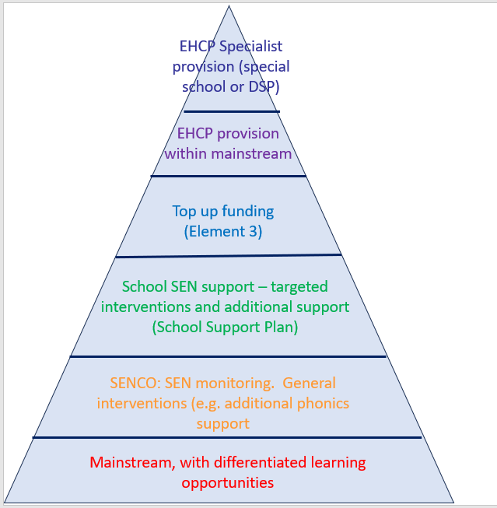

* There is no requirement from Leicester City Council for schools to use the SEND Support Plan however it may assist when:
  + Requesting support from SEND Support Services - LCI, SEMH, CPS, VI, HI (the Early Years Support Team have a similar but bespoke form)
  + Applying for Element 3 (E3) top up funding or reapplication of funding (sections required for E3 are marked with *)
  + Gathering supporting evidence of a graduated approach when applying for an EHCP assessment
  + Supporting parent to understand the graduated approach and ways in which the school is supporting their CYPs needs
* The form should be used in line with schools’ processes and systems. Information for some sections may be collected elsewhere (e.g. intervention or school-based assessment data). In an application for support or funding, these can be submitted as additional documents.
* The plan template can be personalised to the CYP (e.g. including a photograph of the CYP) and school (inclusion of school logo, addition of elements appropriate to the school).
* Attainment data should be appropriate to the CYP, for example reading, writing and maths in KS1 and KS2 or English, maths and engagement in KS3 and KS4.
* If a CYP attends an Alternative Provision, sections should be added to record the reasons for this provision and progress towards outcomes at the provision.
* Additional supporting documents outlining the support in place for the CYP could include:
  + Specific BERA documents
  + Positive Handling Plans
  + Individual risk assessments
  + Outside agency reports and assessments

**Leicester City SEND Support Plan (Pupil Outcome Plan)**

(* Aspects can be used to support Element 3 application)

|  |  |  |  |  |  |  |  |  |  |  |  |  |  |  |  |
| --- | --- | --- | --- | --- | --- | --- | --- | --- | --- | --- | --- | --- | --- | --- | --- |
| **Name:** | | | **Area(s) of need** *(highlight below)* | | | | | | **Key attainment and attendance information\*** | | | | | | |
| **DOB:** | | | **Cognition & Learning** | | | | | | *Subjects:* | |  | |  |  | **Attendance** |
| **Current year group:** | | | **Communication & interaction** | | | | | | **End of previous year** | |  | |  |  |  |
| **Current class/form:** | | | **Social, Emotional & Mental Health** | | | | | | **T1 Aut 1** | |  | |  |  |  |
| **Home language:** | | | **Sensory & Physical** | | | | | | **T1 Aut 2** | |  | |  |  |  |
| **Current support:**  *(highlight)* | **SENDCo monitoring** | | | **School support** | | | **In receipt of top up funding (E3)** | | **T2** | |  | |  |  |  |
| **T3** | |  | |  |  |  |
| **Pupil Voice\*** *Amend as appropriate to age/needs and including: What I like, what I am good at, what I don’t like, what I find difficult; who helps me at home and at school; what could be better at home and school; what I would like to do in the future (job, next stage)* | | | | | | | | | | | | | | | |
|  | | | | | | | | | | | | | | | |
| **Parental Views\*** *Summarise the person with parental responsibility's views regarding the support they feel their CYP needs* | | | | | | | | | | | | | | | |
|  | | | | | | | | | | | | | | | |
| **CYP’s Story\*** *A brief background and timeline of support so far* | | | | | | | | | | | | | | | |
|  | | | | | | | | | | | | | | | |
| **Summary of CYP’s Needs\*** *Provide details of the CYP's strengths and what they find difficult and/ or diagnoses related to their area(s) of need* | | | | | | | | | | | | | | | |
| **Communication and Interaction**  **Cognition and Learning**  **Social Emotional and Mental Health**  **Sensory/Physical/Medical** | | | | | | | | | | | | | | | |
| **Details of any school-based assessments\*** *Or reference/attach other documents where this information is stored* | | | | | | | | | | | | | | | |
|  | | | | | | | | | | | | | | | |
| **Summary of professional/outside agency involvement\*** | | | | | | | | | | | | | | | |
| **Professional involved** | | **Date, start and end** | | | **Summary of involvement** | | | | | **Implementation of advice** | | | | | |
|  | |  | | |  | | | | |  | | | | | |
|  | |  | | |  | | | | |  | | | | | |
|  | |  | | |  | | | | |  | | | | | |
|  | |  | | |  | | | | |  | | | | | |
|  | |  | | |  | | | | |  | | | | | |
| **Pupil outcomes/targets and provision* (Indicate where provision is supported by E3 funding)**  (QFT, interventions, TA support, reward and sanction systems, support and scaffolding cards, work buddies, seating arrangements, home/ school communication etc) | | | | | | | | | | | | | | | |
| **Outcomes/Targets**  *CYP centred, clear, related to need and achievable* | | | | | | | | **Provision, support and intervention**  *Linked to outcomes including: inclusive mainstream teaching, reasonable adjustments, interventions, TA support, scaffolding, prompts, seating arrangements etc.* | | | | | | | |
|  | | | | | | | |  | | | | | | | |
| **Reviews and Comments (including parents and CYP)\*** *Include actions of what the parent will do, CYP will do, school will do, outside agency will do* | | | | | | | | | | | | | | | |
| **Academic year:** *e.g. 2024-2025* | | | | | | | | | | | | | | | |
| **Term 1** | | | | | | **Term 2:** | | | | | | **Term 3: Date** | | | |
|  | | | | | |  | | | | | |  | | | |
| Review date: | | | | | | Review date: | | | | | | Review date: | | | |
| **Academic year:** *e.g. 2025-2026* | | | | | | | | | | | | | | | |
| **Term 1** | | | | | | **Term 2:** | | | | | | **Term 3: Date** | | | |
|  | | | | | |  | | | | | |  | | | |
| Review date: | | | | | | Review date: | | | | | | Review date: | | | |

*Continue reviews below*